

Promoting and developing a vibrant third sector in the Scottish Borders

Scottish Borders Community Spaces Decarbonisation Fund 2025/26

Guidance for Applicants
April 2025

Scottish Borders Community Spaces Decarbonisation Fund
Guidance for Applicants

- About the Fund
The £650,000 Community Spaces Decarbonisation Fund has been established as part of the Community Regeneration Partnership (CRP), in collaboration with the Ministry of Housing, Communities and Local Government (MHCLG), Scottish Borders Council, and Borders Community Action.

- Fund Aims and Outcomes

This fund aims to:

- Support the decarbonisation of village halls and community centres in the Scottish Borders.
- Reduce energy costs and carbon emissions by improving energy efficiency and installing renewable energy solutions.
- Enhance the sustainability and resilience of vital community spaces to serve local residents now and in the future.

- Who can apply?
Eligible applicants must:
- Be a third sector organisation/ committee responsible for managing a village hall or community centre in the Scottish Borders.
- Hold ownership or a long-term lease (minimum 5 years) of the building or demonstrate formal responsibility for its management.
- Be committed to improving the energy efficiency of the space and reducing its carbon footprint
- Have obtained an independent energy audit (or apply for an audit as a first step).
- Have the capacity to deliver the project and comply with reporting requirements.

The range of organisations eligible to apply are:
▪ Scottish Charitable Incorporated Organisations (SCIO)
▪ Unincorporated Associations
▪ Companies Limited by Guarantee
▪ Trusts
▪ Not-for-profit organisations such as charities and asset-locked organisations such as Community Interest Companies (CIC)
▪ Cooperative and Community Benefit Societies
▪ Committees responsible for a space operating under a constitution

4. What Can Be Funded?
Funding will support projects aligned with a structured retrofit roadmap to improve energy efficiency in community buildings:
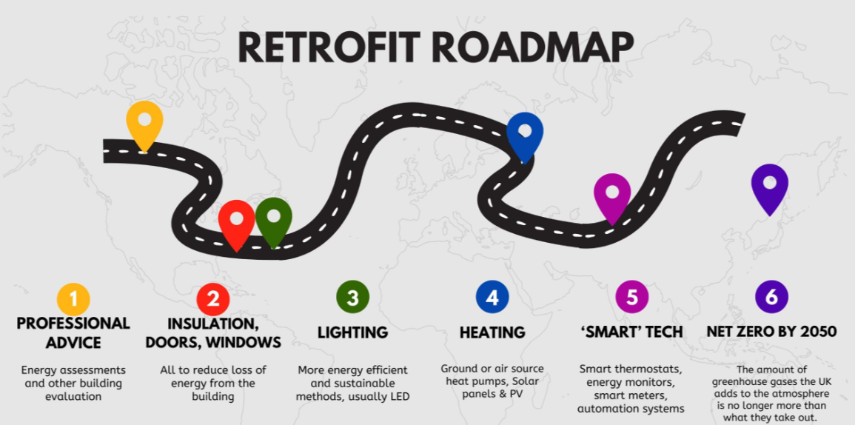
Applicants must have completed previous retrofit stages before applying for subsequent stages. Funding is available for one stage at a time.
Stage 2 – Building Fabric Improvements
- Wall insulation
- Underfloor insulation
- Loft insulation
- Window and door replacements
- Draughtproofing
Stage 3 – Energy Efficiency Upgrades
- LED lighting improvements
Stage 4 – Renewable Energy Solutions
- Solar panels
- Heat pumps
- Battery storage
- Water heaters
Stage 5 – Smart Energy Management
- Digital controls (thermostats, heating controls, automation systems)

5. Funding & Financial Requirements
There’s no limit to the total amount organisations can apply for, as long as the total costs are for the retrofit measure identified in the staged process of the Retrofit roadmap.
Applicants must provide a detailed cost breakdown for their project. The following procedure must be considered when applying:
Value | Minimum Procedure | Advertising Required
£0 - £5,000 | Direct Award None | None
£5,000 - £50,000 | Minimum of 3 quotes or prices sought  from relevant suppliers of goods, works and/or services. | £5,000 - £50,000
Over £50,000 | A formal competitive tender process must be undertaken. Copies of advert(s), brief, returned tenders and scoring process to be provided.  Tenders should demonstrate:  - The weighting of the tenders to show reasonableness of costs selected.  - The successful tender has the relevant experience and expertise to carry out the work.  - The financial security of the contractor appointed to carry out the work.  - Genuine and effective competition for the tender. | Yes. Openly advertised in  appropriate media (e.g. trade  websites/magazines/journals  etc.)

We encourage applicants to use local contractors as much as possible. Although we understand this is not always possible due to the availability of local traders and suppliers.
Match funding is encouraged, particularly for Stage 4 retrofit measures but not required. Applicants should disclose additional funding sources, including:
- CARES (Community and Renewable Energy Scheme)
- Federation of Village and Community Halls
- Wind Farm Community Benefit Funds
- Other grants or contributions

6. Planning & Compliance
If planning permission is required, applicants must have secured it before applying. The project must be fully completed by the end of February 2026.

7. Organisational & Governance Requirements
Applicants must demonstrate strong governance and project oversight capacity, providing:
- Number of committee members
- Number of active volunteers
Organisations must disclose any Minimal Financial Assistance (MFA) received within the last two financial years, ensuring compliance with the UK Subsidy Control Act 2022. More information can be found here: Subsidy Control: a guide for beneficiaries

7. Application and Monitoring Processes
Successful applicants will be asked to adhere to all monitoring, evaluation and reporting requirements in the grant offer letter.
Reporting requirements will be in keeping with the level of grant offered. Small recipients will be asked to complete a simplified form about their activities and what was achieved; photographs are always welcome too. Medium and larger grant holders will be expected to provide case studies, key figures or statistics, stories and photos, and the mid-term and final reporting. Project visits and promotional activities will be encouraged.

7. Deadlines
The fund stays open as long as funds remain available. Applications will be assessed on a weekly basis. Applicants will be notified of the decision and grant offer letters will be sent to successful applicants once an award decision is made.

