Strategic meeting:
Local Employability Partnership

Date of meeting:  30/01/2025 | Attended by:  J Amaral
Relevant agenda items:

- RSA Update - Greig Robson (SDS)
- Intervention Update
- NOLB Funding Update
- AOB
- Interim Participation Snapshot
- Border Careers Collaborative
- BCA Mapping and Gapping Report and new employability webpage.
- Partner Updates / Spotlight Sessions

Specific points of interest:

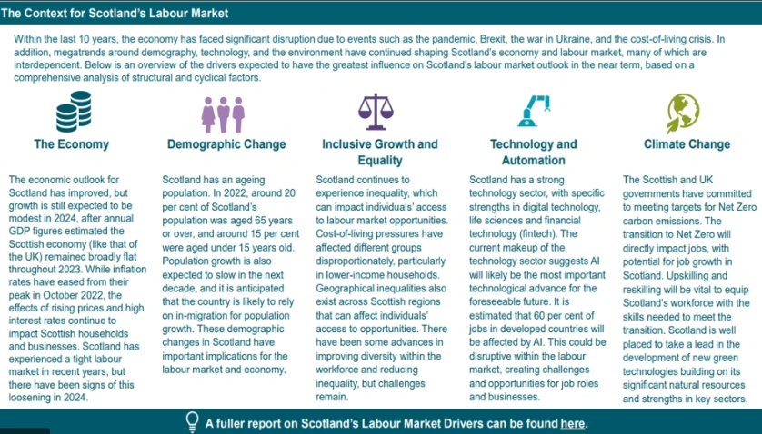

Greig highlighted workforce decline in the region and the forecast in 10 years time which should see a small increase, with main sectors in the Borders being:
- Human Health and social work
- Wholesale and retail
- Education
Employment by occupation:

- Administrative occupations
- Health professionals
- Corporate managers

Replace and demand of the workforce is being impacted by retirement and the ageing populations across Scotland.

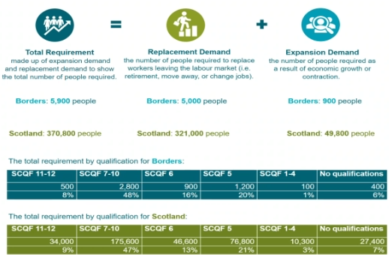

Further/ Higer education and apprenticeships systems likely to be the key as part of industry demand

Drive to net zero is changing jobs but mostly through existing jobs changing or through increased demand for existing occupations, such as electrician skills.

Mental health and low qualification have a significant impact on economic inactivity.

NOLB Funding Update

Lana provided an update on funded projects:

• Borders Additional Needs Group (BANG) – Transition Service
Target audience is young people aged 16-25 years with Additional Support Needs
There are currently 34 young people registered with the service with an average of 5 referrals a week.
The young people are accessing support for emotional wellbeing, benefits, transport, job applications and interview support.
17 have accessed bespoke work experience opportunities in collaboration with Archaeology Scotland, Hike and Bike, R-Evolve, and Live Borders.
18 young people have accessed volunteering opportunities through BANG, Café Re-Charge, a local food pantry and local charity shops.
And 8 young people are registered on the yearlong YES programme where each participant takes on a job role and works as part of a team, with responsibility for an area of part of the business such as finance, sales, or marketing. They are responsible for making all the decisions about their social enterprise including deciding on the name, product and running pop up shops. This helps them to work on developing key employability skills and they will gain an SCQF level 3 award at the end of the course.

• ReTweed – Skills for Work in Textiles
This was a pilot to be delivered in partnership with Borders College over 12-weeks for 8 students prioritising those far-removed from employment and young people facing multiple and complex barriers.
There were 8 students on this course initially, 2 of the participants presented continued problems with attendance with one of them leaving halfway through the course.
Of the 7 remaining students 6 of them presented their projects to the group at the end of the 12 weeks, which was a big step for them as they had struggled with confidence at the start of the course. All 6 students completed the modules and individual project, earning them the Nat 5 accreditation.
All 7 students engaged with international Tartans and also had individual meetings with ReTweed’s employability support officer who will continue to support them now the course has completed. In summary
One of the students is looking into further education and teaching in textiles.
Two students will complete ReTweed’s advanced skills course and hope to get involved in freelance manufacturing with international tartans.
One student has decided that textiles isn’t for them but has gained the confidence to now look for work.
One student is hoping to use the skills gained to improve her new accessories business.
And one student is looking to earn the qualifications needed for a nursery nurse course.

• R-Evolve – Target the Position Train for the Job
A small cohort of 3 started this intervention in Selkirk at the end of last year, and there are now 2 more courses running, one in Galashiels and one in Hawick with 16 participants taking part over the 2 courses. We will keep you updated on progress.

• Bruce Robertson – CSCS Card Training
The full 50 places have now been utilised on this course and we are awaiting feedback on outcomes from DWP.

Andrea provided a presentation of the Interim Participation report, providing an overview of participation at a national and local authority level and is based on data sourced from the SDS Customer Support System (CSS). CSS is directly updated by SDS staff and through data shared by partners (including local authorities/schools, colleges, SAAS, DWP). This dataset is also used to produce the Annual Participation Measure (APM) and to provide data for the Scottish Government’s School Leaver Destination Statistics.

The interim participation snapshot will be updated in December and May, however, data sharing partners in local authorities and colleges can continue to access their own data at any time through the 16+ Data Hub.

Scottish Borders is the 6th well performing local authority across Scotland in terms of participation. The bottom intermediate zones are Langlee, Burnfoot and Bannerfield. There was a wide conversation around interventions in these areas and support that could be put available.

Borders Careers Collaborative – this is a newly formed group in the Borders:
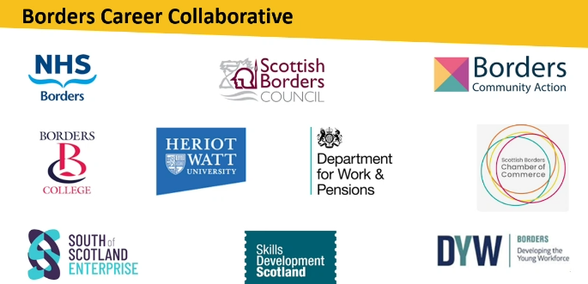

Key challenges:
- Raising awareness of support
- Employer engagement
- Transport

How can the collaborative make a real difference:
- Develop a know your network event (3-6 months)
- Cohort specific provision (3-6 Months)
- Community Career and Job Fair (6-12 months)
- Employer Event (6-12 months)
- Meet again in February

BCA Mapping and Gapping report and Employability webpage: https://borderstsi.org.uk/employability/
The full report can be found here:
https://borderstsi.org.uk/wp-content/uploads/2025/01/employability-mapping-and-gapping-report.pdf

The visual map will be updated continuously, and a new functionality has been developed on our website for the map to be updated by organisations directly.

LEP presence: there was a wider conversation around a website presence and using existing platforms to promote the LEP and LEP activities.

Partner spotlight – The LEP is looking to develop further knowledge of the work partners do.

Actions from this meeting:
None

Distribution list for information:
BCA Team + Third Sector Leaders

Signed: J Amaral

