Strategic meeting:
Wellbeing Programme Board

Date of meeting:  07/01/2025 | Attended by:  J Amaral
Relevant agenda items:

- Physical Activity Opportunities: Jen Knox / Graeme Murdoch (15 mins)
- Implementation & Development of Local Area Co-ordination (LAC) in the Scottish Borders: Simon Burt, Claire Veitch, and Ralph Broad (45 mins)
- Commissioning Update: Bryan Davies (10 mins)
- Communities Mental Health and Wellbeing Fund – Round Three Fund Allocation Overview: Juliana Amaral (10 mins)
- The Round Two Update for the Scottish Borders is available here: CMHWF Impact Report Scottish Borders - December 2023.pdf.
- Any Other Business
Specific points of interest:

- Physical Activity Opportunities: The Health Programme aims to reduce health inequalities and improve health outcomes and quality of life for adults living in our communities, by providing opportunities to increase physical activity levels in a safe and accessible environment with the support of qualified Health Instructors.​ Programmes provided:
Exercise on Referral​ - Adults with long-term health conditions can be referred into the Live Borders Health Programme by their Health or Social Care Professional.​
LIVEwell Programme​ – aimed at older adults, adults new to exercise and adults that are at risk of developing health conditions in the future. ​
Other activities:
EMPLOYABILITY PROJECT​ - Funded by SBC NOLB fund​ In Partnership with Economic Development and Child Poverty teams at SBC​
GOOD BOOST​ - Funded by one-off legacy donation to Live Borders​ In partnership with NHSB MSK Physio Dept​
COUNTERWEIGHT​ - Funded by NHSB​ In Partnership with NHSB and BWMT
CANCER PREHAB PATHWAY​ - Not Funded​, in partnership with NHSB​
DISABILITY WELLBEING MEMBERSHIPS​ - Funded by Community Mental Health and Wellbeing Fund​ In Partnership with Borders Disability Sport​
ONCE FOR SCOTLAND​ - Not Funded - In partnership with CLUK, Public Health Scotland and Edinburgh Napier University.​ Data collection and programme evaluation across Scottish Health Programmes.​

Graham Murdoch presented the sports and Physical activity strategy placing particular emphasis on volunteers leading sessions in schools and out in the community through sports clubs. 8 strategic delivery priorities​:

Enabling the Physical Activity & Sport system​
Sport and Active Recreation for all​

Active Places of Learning​
Active Travel​
Active Places & Spaces​
Health & Social Care​
Communications & Public Education​
Active Workplace​

Local Area Coordination Service:
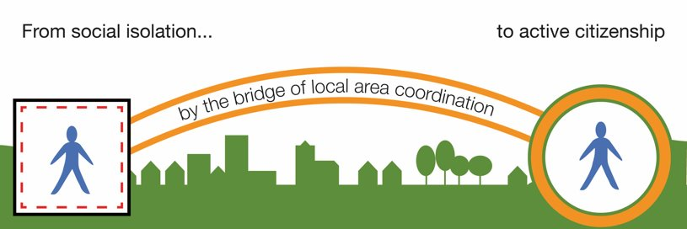

Vision is that “All people in the Scottish Borders are able to live their lives to the full”​

Strategic alignment:

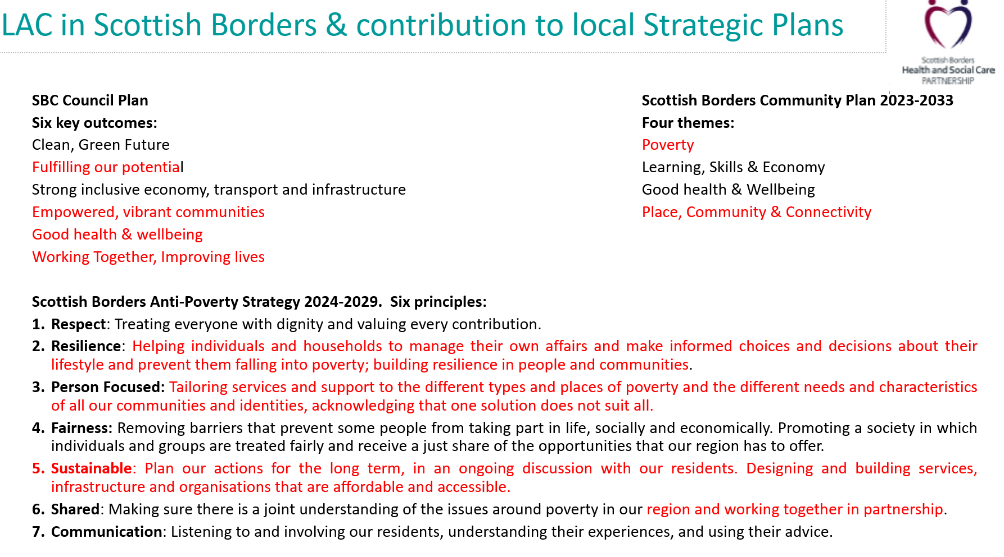
Scottish Borders Health & Social Care Partnership views Local Area Co-ordination as having a crucial role in contributing to the vision and objectives set out in the Strategic Framework. Here are just a few examples:​​
Taking a place-based and strengths-based approach that builds the capacity & resilience of individuals, families & communities through relationships & contributions. A preventative approach that reduces demand.​
​Acknowledging and nurturing the people, places and resources within communities, as fundamental sources of support, has a clear alignment with our place-making agenda and plans for embedding locality working.​
​Addressing inequalities by being accessible and visible in local communities and supporting the nurturing and development of strong communities that are inclusive of all citizens. Key to addressing social isolation & loneliness; some of the determinants of health inequalities.

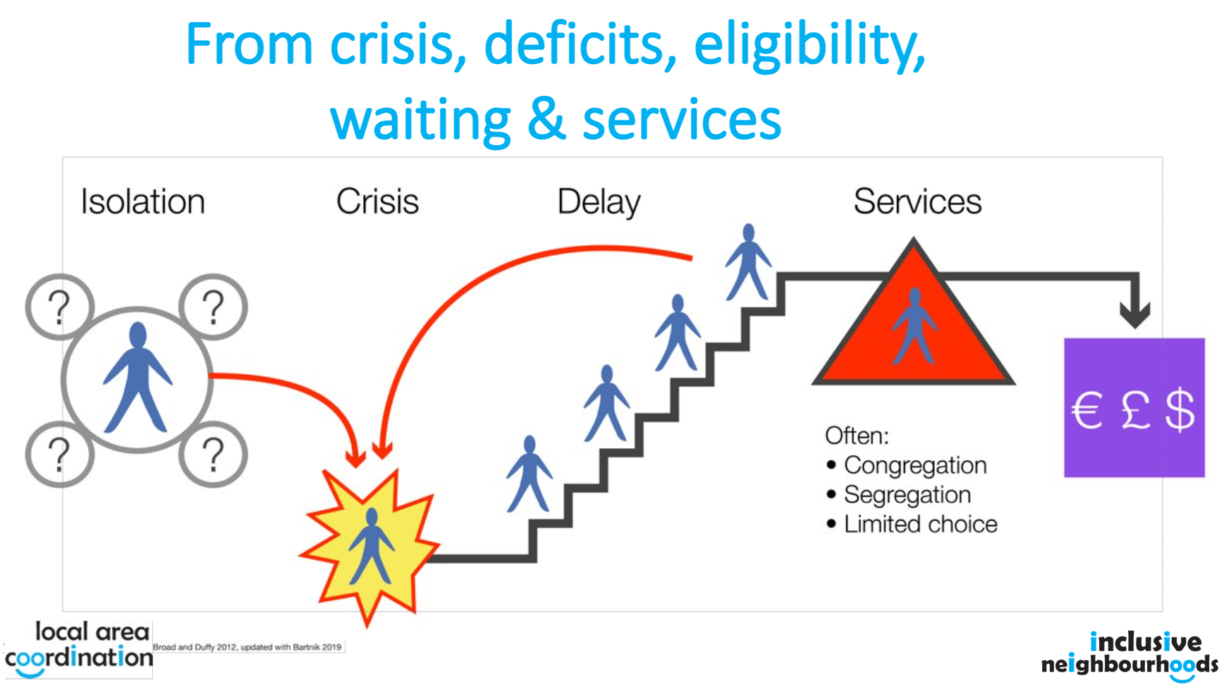

Juliana asked regarding investment considering services are already at capacity. This was particularly in relation to service users’ ongoing support needs and timeframes. This was well received and the response to this is a strong multiagency partnership approach which is currently under discussion as part of the LAC re-design.

Due to time, the other agenda items were postponed to future meetings.
Comments:

Focus on volunteering in promoting physical activities in the community and third sector role in supporting the LAC model in communities.

Actions from this meeting:
Juliana to discuss the third sector role as part of the LAC re-design

Distribution list for information:
BCA Team + Third Sector Leaders

Signed: J Amaral

