Strategic meeting:
Integration Joint Board

Date of meeting:  22/01/2025 | Attended by:  J Amaral
Relevant agenda items:

- Health and Social Care Partnership Performance and Delivery Report
- Audit Scotland Annual Audit Report
- Tweedbank Care Village
- Financial Planning 2025/26
- IJB Risk Management

Specific points of interest:

Health and Social Care Partnership Performance and Delivery Report
Chris Myers provided an overview of the Health and Social Care Partnership delivery report highlighting GP hours activity, which has been in the region of 86K per month. The adult SW waiting list has declined, with no waiting lists in Teviot and Berwickshire.

Currently, there is no homecare waiting list, and travel time and continuity have been improved. Challenges in rural areas with 50% of the population living in rural areas. Extra provision has been allocated to Berwickshire. Home first and enablement plans will further reduce waiting lists. Recharge to assess the pilot model will also increase capacity in Central.

- Living Well strategy to support unpaid carers – Promoting Care Positive Pathways – information session for employers on 5th February - https://www.eventbrite.co.uk/e/carer-positive-awards-information-session-for-employers-tickets-1044793614827?aff=oddtdtcreator
- Home Energy Scotland partnership – 304 people supported this year.
- Local Area Coordination model review continues to happen, an update information will take place later in the year.
- Unscheduled care pressures – need to unlock capacity within social care with pressures not only in emergency response but also in care support and assessment. Despite improvements, there are still complex pressures on staff and morale as a result is affected.
- Warm well – Chris provided an update regarding the £30K investment for the development of warm spaces. Due to the short timeframe it has not been possible to go ahead with the plans, particularly as the partners wanted to ensure clear evidence of targeting those most at risk and the positive impact of these types of interventions on those who need the most.

Wider discussions and concerns regarding the impact of children and young people’s mental health support and assessment waiting, as well as staff in the community who are supporting these children while waiting for CAMHS support. This is particularly concerning in light of the drop off of third and independent sector provisions.

Audit Scotland Annual Audit Report – the report recognises to material changes.
Accounts £4.5M overspend. Pressures of £3.6M including A&E costs.
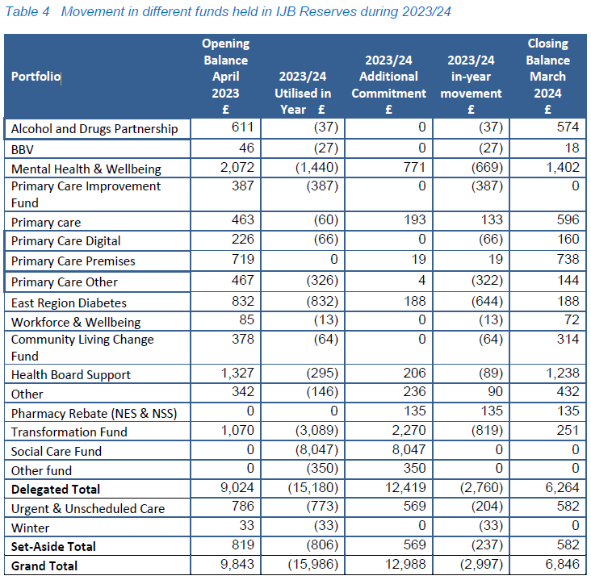

Significant financial risks which require management and mitigation include:
58
• Underlying savings targets within delegated budgets.
• Service pressures and new policy decisions which are not fully funded by the Scottish
Government eg the Coming Home Project and elements of pay deals.
• Workforce sustainability for health, social and independent/third sector partners.
• The potential loss of service provision as a result of market failure.
• Ongoing inflationary pressures in key areas e.g. utilities, pay and transport.
• Real term reductions to partner funding.
• Reducing Scottish Government allocations .
• Prescribing - due to the volatility of price and volume of prescriptions.
Continue implementing the Communications & Engagement Plan – internal and external
Continue to engage and update teams and services – ‘You said, We did’
Further modelling work will be undertaken to mitigate a reduction of DDs, and capacity provided by community-based services
Finalise the Winter Plan – approval at BET 26/11
Sign off at Board in early December 5/12

The budget was approved.

Tweedbank Care Village – This is a proposed innovative new model of residential care, designed specifically to better support the changing needs of older people alongside providing high-quality care and support through proactive early intervention and preventative action
aimed at those with complex needs, frailty, and dementia.

The concept of the care village model supports unique needs, lifestyles and personal preferences for
living, care and well-being for people living mainly with dementia and frailty. The focus is on
possibility rather than disability and will be supported by 24-hour care, delivered by trained
professionals.

The proposed model of care for the Tweedbank Care Village and the associated
running costs were presented for approval.

Staffing

The staffing requirements have been developed in conjunction with the service and the
structure tested by the service to ensure this works with their current rota model. The
proposed staffing structure is detailed below in table 1 and has an associated cost of
£2,565,151 in the 2026/27 financial year.
The estimated 2026-27 staffing costs are based on actual 2023-24 costs and uplifted in line
with current SBC manpower budgeting assumptions used for 2024-25 5-year revenue plan.
An assumption has been made that any training costs are covered centrally by the training
department.

Volunteers

Volunteers will be used wherever possible to enhance services within the care village by
the provision of ‘interest groups’ e.g. gardening/food growing. Community groups could also be
given free use of the village hall/café if they can accommodate suitable residents within
their groups. There would be no additional costs associated with this.

Social enterprise proposal

The provision of a shop and hairdressers will be met through the Social Enterprise route by joint
working with Borders Community Enterprise (Borders Community Action – correction was made at the meeting). Initial discussions have taken place and there is no revenue funding required to support this initiative. Any profits generated through the provision of social enterprises will be reinvested into the care village in line with residents’ input as to what the funds should be spent on.

There is all potential to enhance the café by using a social enterprise to run a service that is in
addition to the lunch and evening meal service that will be provided by SBC Catering staff.

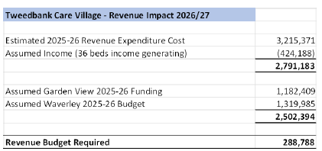

Further details are to be provided in terms of staffing and costs however the direction of the project was approved to be reviewed once more information is provided.

Financial planning for 2025/26

All funding for the Health and Social Care Partnership is allocated from its partners, NHS Borders
and Scottish Borders Council. Whilst this additional funding supports the IJB’s financial position during 2024/25 there is a significant risk to the future financial sustainability of the IJB due to current running costs of services compared to the level of funding available which will need to be addressed through the
Financial Planning Process. Services continue working to reduce running costs through innovation,
efficiency and increasingly tough spend criteria however the IJB will need to fundamentally
consider how and what services are delivered in order to ensure its sustainability in the short,
medium and long term. This will be more fully explored as part of the IJB’s 5-year medium-term
financial plan.

NHS Borders will receive total baseline funding of £303.7m in 2025/26. This excludes any additional allocations which are received from Scottish Government throughout the year.
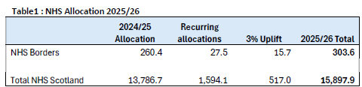

Between now and March, the HSCP will continue to review its delivery plans for 2025/26 and
future years. As previously discussed, it will not be possible to sustain all the services currently available unless significant additional funding is made available. Ongoing work that will influence the medium-term plan includes;
- Buchan and Associates, reporting in January 2025 on the bed capacity needs for the
Scottish Borders
- Learning Disability needs assessment, to understand the required level of service across
the Scottish Borders, recently commissioned.
- NHS Borders delegated services continue to progress plans to deliver further
reductions of 3% in 2025/26 and 2026/27.
- Scottish Borders Council delegated services continue to identify areas of prioritised
spend within 90% of their existing budget.
- Further work on integration, redesign and the potential for reduction of some services
is also being considered including further integration of management structures and IT
systems to improve operational integration.
- A new NHS Borders Strategy currently being developed. As our new IJB Strategic
Commissioning Plan for 2026-2029 will require to be developed next year, this gives us
the opportunity to work closely with NHS Borders and Scottish Borders Council to align
and integrate our new Strategic Commissioning Plan for 2026-2029 closely to the plans
our NHS Borders and Scottish Borders Council, as we did for our current Strategic
Framework 2023-2026.
- Work to consider the commissioning of home care services
- Continued progress to develop Self Directed Support
- Continued rollout of client movements as detailed in the Coming Home paper.

The financial information was noted.

IJB Risk Management

The Risk Management Policy and Strategy states that six monthly risk reviews should be
presented to the Board each year. This second report of 2024 outlines the progress made in
November 2024 to review the IJB Strategic Risk Register. It is anticipated that the next Strategic
Risk Update will be provided in alignment with the relevant progress updates on the Delivery
Plan in 2025.
There is a significant funding gap which historically has been filled with brokerage funds however, this is not going to be available moving forward. Staffing costs in Scotland are also higher compared to England which adds further pressure on budget allocations.

Actions from this meeting:
BCA to discuss planning for Warm Well/ Warm spaces 2025.
BCA to follow up on the discussion with Julie Glen regarding volunteering and social enterprise model at Tweedbank Care Village.

Distribution list for information:
BCA Team + Third Sector Leaders

Signed: J Amaral

