Strategic meeting:
Wellbeing Programme Board

Date of meeting:  03/12/2024 | Attended by:  J Amaral
Relevant agenda items:

- Communities Mental Health and Wellbeing Fund Update: Juliana Amaral and Lorna McCulloch
- ALISS – Michael Curran
- AOB

Specific points of interest:

Juliana and Lorna provided an overview of the round 4 of Communities Mental Health and Wellbeing fund
The
Fund opened on 01 August 2024 and closed at 5pm on 30 September 2024. During this time, BCA team delivered network and 1-1 support events focused on this fund A video to support applicants was prepared 3 online sessions delivered 8 in-person capacity building sessions:
Walkerburn, Melrose, Jedburgh, Eyemouth, Duns, Peebles, Hawick, Drygrange - A total of 98 people attending.
A total of £320,000 in funding available from Scottish Government, 91 funding applications received with a total request of £1.320,685
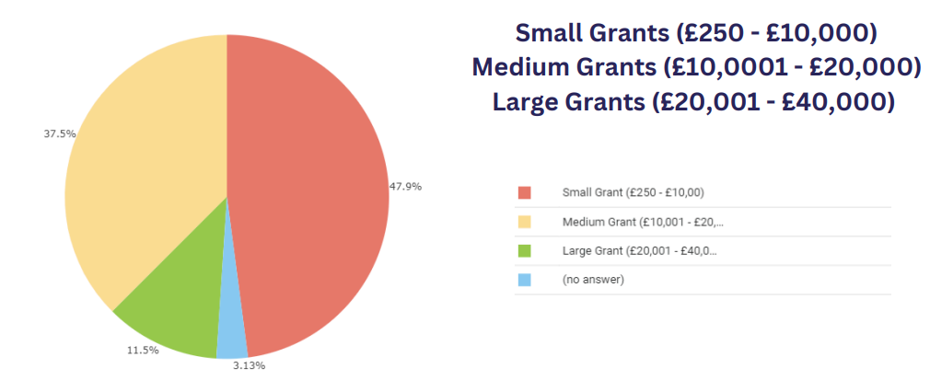

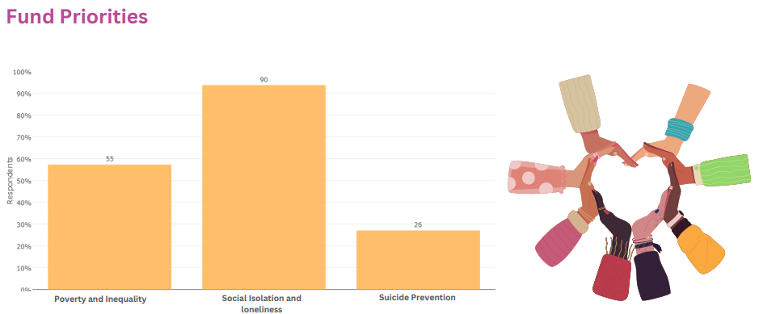

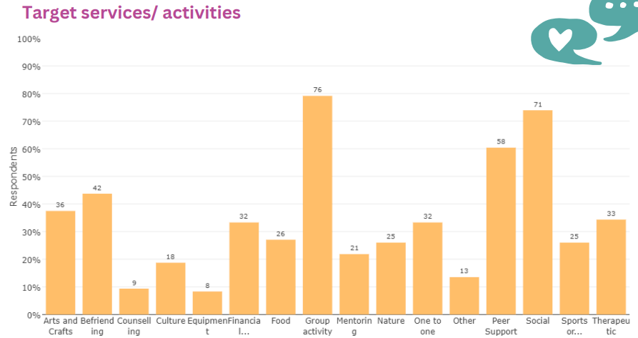

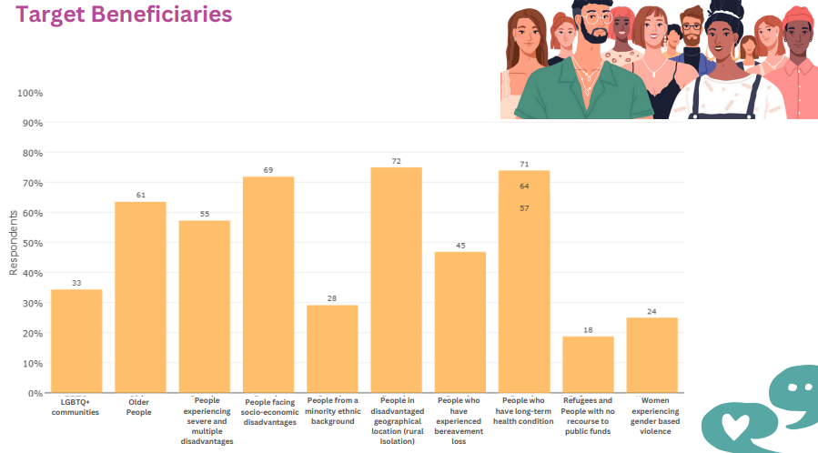

Due to the volume of applications received, the independent panel scored applications above £5K, and applications below £5k were scrutinised by the development officers. This is because there’s a key requirement from the Scottish Government that at least 50% of the fund is allocated to small, grassroots projects. A threshold of 60% scoring was created so the independent panel could score each application based on fund aims, at-risk target groups, value for money, impact for medium and large grants, and evidence of partnership work. Lorna provided an overview of the process and presented the dashboards:

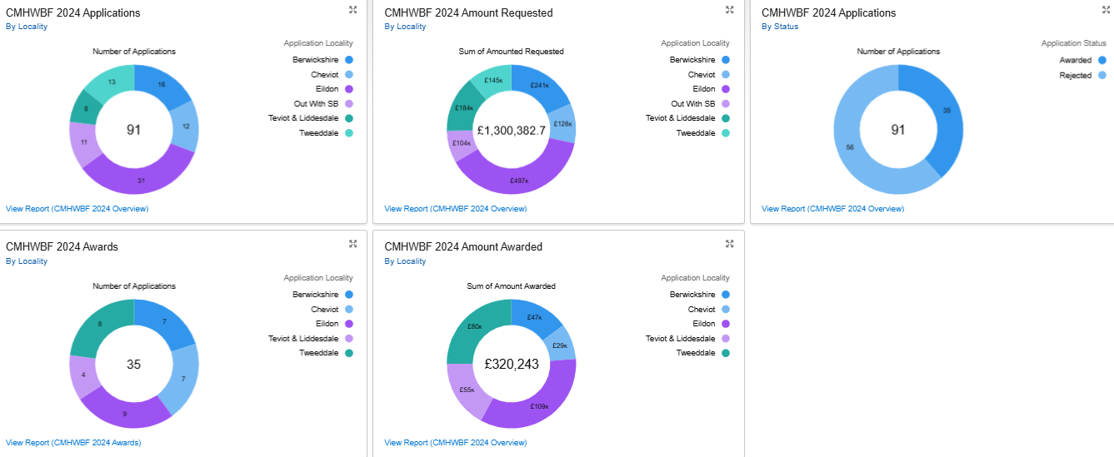

The Board deliberated widely about the at-risk target groups and the need to build evidence based on the needs and reach of the most at risk in communities. Wendy suggested further learning regarding equality's impact for community-based activities. Juliana invited Wendy Henderson (Equalities Impact) to be part of the evaluation process.
Concerns were raised in terms of levels of applications from Teviot and Liddesdale which is inconsistent with previous rounds. Moving forward, the Board recommended that stronger focus be placed on those communities where areas of multiple deprivation have already been identified.

There were also concerns regarding the support to unsuccessful applicants moving forward, due to the high volume of applications received. Juliana and Lorna re-iterated that this is currently being addressed with sessions running in the new year in partnership with the national lottery regarding the fund opening.

The Board recognised the amount of work involved in this process and congratulated BCA for the work done. The process was endorsed with a couple of recommendations in terms of the reach of projects across localities and consideration of those most at risk.

ALISS - Michael Curran provided an update on ALISS - ALISS is funded by the Scottish Government and is part of the wider Health and Social Care Alliance (Scotland). ALISS has the vision that the people of Scotland should be able to access the information they need to help them live well.

The proposal below includes work to ensure a Borders-specific home page through which all information in ALISS is accessed.
The aims of the project and introduction of ALISS:

- To increase the availability and accessibility of information about services, groups, activities, and resources that can impact the health and wellbeing of the people of the Scottish Borders, particularly those living with long-term conditions, disabled people, unpaid carers, and people facing disadvantage.
- To support people, communities, professionals, and organisations to share information on services, groups, activities, and resources that can impact the health and well-being of the people of the Scottish Borders.
- To thereby make a significant contribution to improving the health and wellbeing of the people of the Scottish Borders.

There was a wide debate about the need for a local directory and the resources required to develop and maintain such a system.

The Board agreed to endorse the plan and asked Michael to do further work on the financial calculation required for this.

AOB – Borders Care Voice invited all to the social event happening on 12/12 as part of their Christmas celebration.

Actions from this meeting:
Juliana to invite colleagues from TS DG to present updates on round 3 CMHWBF on 07/01/25

Distribution list for information:
BCA Team + Third Sector Leaders
Signed: J Amaral

