Strategic meeting:
Integration Joint Board

Date of meeting:  18/09/2024 | Attended by:  J Amaral
Relevant agenda items:

Partnership Delivery Board
Local Area Co-ordination (LAC) service review
Coming Home Programme
Alcohol and Drugs Partnership
IJB Budget overview

Specific points of interest:

Partnership Delivery Board – significant challenges in terms of pressures for GP demand however, survey responses on users experience has been positive.

Gwyneth Lennox provides an update on social work assessment – on target moving to single figures across the localities by next March. Community Led Support and What Matters hubs has helped reduced waiting lists. Berwickshire and Cheviot has been reformed and progress has started to be experienced. Staffing is still an issue with same staff covering social work day to day work and providing assessment at locality hubs. Improved outcomes means early prevention and intervention across the Borders. Locality staff has been helping hospital to home team which has sped up assessment work in line with the whole systems approach. Early access to social work also means crisis avoidance.

Carers Centre – pointed out how positive this work has been and asked the questions regarding data in relation to improved outcomes to people. Gwyneth is looking at mapping and quantifying outcomes in relation to people’s engagement with services including the third sector. Information to be reported to IJB in the future.

Vaccination programme (JCPI) including flu and covid, has commenced across Scotland, older adults, people with health conditions and pregnant women, aimed at preventing winter pressures too.

Home first and adult social care – review undertaken, positives identified, service specification to be agreed as part of the refresh.
Delayed Discharge + hospital occupancy – numbers are starting to reduce however it would be beneficial to see the correlation between people who required social work/ support input and those who don’t – 92.3% people were discharged without delay last week (145 discharges).

Linda Jackson (Borders Carers Centre) – raised the issue of complex agenda packs with over 300 pages and its accessibility to the wider public. Lucy O’Leary (Chair) – suggested streaming agenda and looking at document format that can provide useful information in an assessment manner. Also important to highlight positive impact. Sohail Bathi also raised the importance of capturing information about protected characteristics.

Cllr Thorton-Nichol raised the issue around Power of Attorneys (POA) and people being kept in hospitals as a result. This has created issues around bed holding at the BGH. Limited powers within legislation are one of the issues in discharging people with POA. Dedicated Mental Health officer has been beneficial.

Unscheduled Care hospital occupancy – increase capacity: virtual hospital, home first redefinition, enhanced residential/ dementia beds
Reducing admissions: locality approach, vaccination, warm and well (fuel poverty), reduction of social work assessments. What can be done to mitigate the risks of poverty and impact on health and wellbeing.

Local Area Co-ordination (LAC) service review – Simon Burt presented the service review report. The report recommends changes within the service such as: management structure, staffing reduction, re-set in approach increasing caseload capacity, focus on community capacity. Service users reported high level of satisfaction with the service.

Research demonstrates that the recommended model works well with 1 LAC per 10,000 population.
Juliana asked the question around budget consideration to allow community capacity building to happen and that the work around this is done in partnership with other development agencies across the Borders, such as Borders Community Action Team. Simon confirmed that no further budget has been allocated but asserted that partnership with third sector is absolutely essential for the survival of this service and service users benefit.

Linda Jackson raised the question around clear communication around the changes to staff and service users, particularly in light of the positive feedback from service users about the current service. Simon Burt clarified that the communication for service users will be provided with a transition to appropriate services when required with the proper planning and engagement.

Decision: the Integration Joint Board approved the recommendation for service.

Coming Home Programme - All the people included within the local Dynamic Support Register will require assessment and potential reprovision of support packages irrespective of Scottish Government’s Coming Home Policy direction as we have a legal duty to provide appropriate care. The report highlights an expected significant increase in costs associated with this work, largely due to the increase in number and complexity of the individuals that need support. Recruiting has been a challenge which has caused a delay in the development of the programme.

The Scottish Borders Health and Social Care Integration Joint Board is asked to:
(a) Note the predicted increase in demand for the Lives Through Friends approach based on data from young people’s services and the ongoing implications for the Learning Disability Service.
(b) Agree to the increase in clinical staff required to support the return home of the 4 Lives Through Friends service users at a recurring cost of £211k to be permanently funded through reduced spend on placements.
(c) Note that there is an anticipated reduction in costs of £0.239m resulting from the placement changes outlined in the paper but significant workforce challenges associated with this programme.
(d) Remit the IJB Chief Officer to commission a needs assessment to determine need/demand and inform the planning approach of the Integration Joint Board. This will be presented back to the Integration Joint Board for future consideration.
(e) Note that the Learning Disability Service is exploring Regional Solutions to provide accessible Learning Disability in-patient services and will bring an update back to the Integration Joint Board in due course.

Alcohol and Drugs Partnership – Fiona Doig provided an update on the survey submitted to the Scottish Government and the 3-year strategic plan
Stigma for people in communities seeking support, other partners such as We Are With You also supported developing a communications plan.

The Strategic plan has been updated highlighting the areas for improvement, and purposeful engagement with colleagues through the Equality Impact Assessment has been positive with key information gathered from people with lived experience. Some of the recommendations have already been acted upon due to the agility of this process. Seeking approval of the survey and the Impact Assessment.

IJB Budget overview -

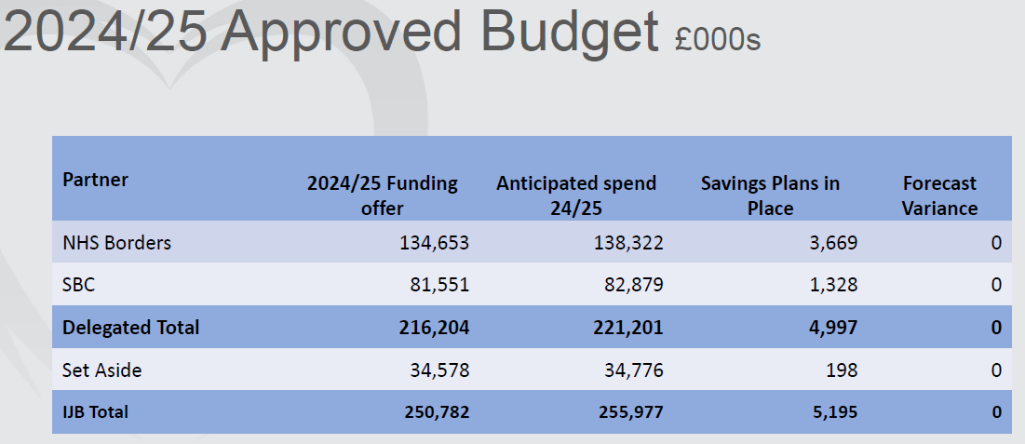

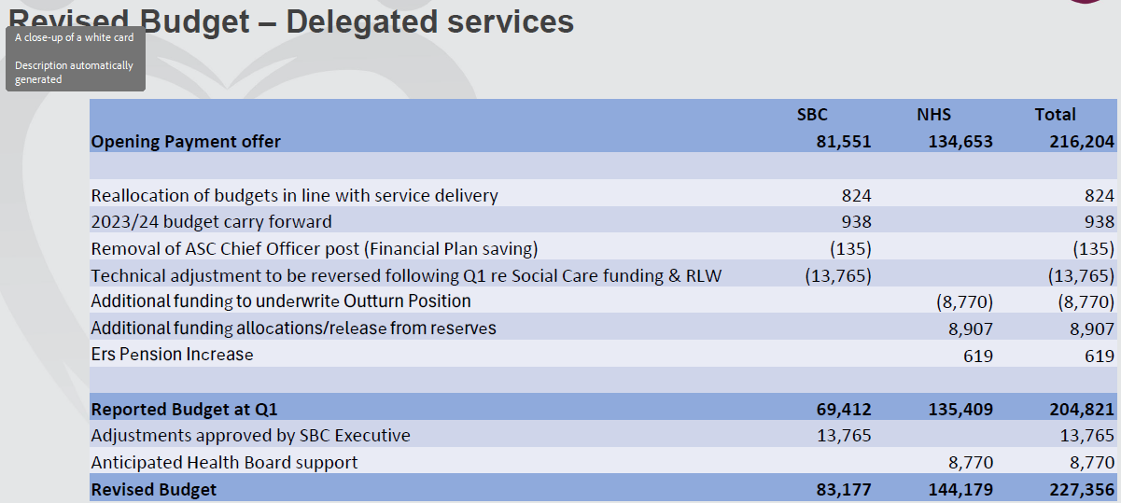

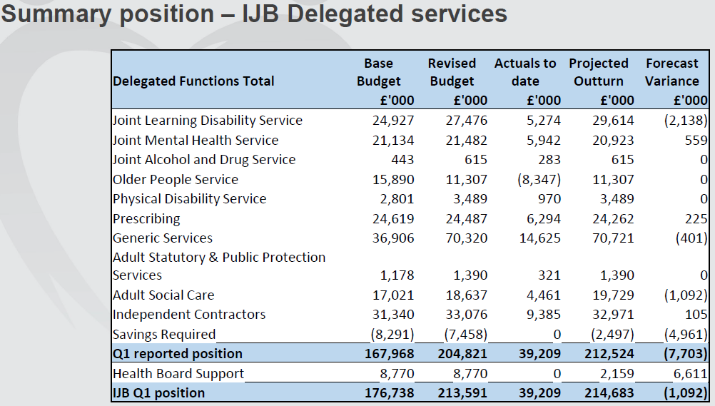
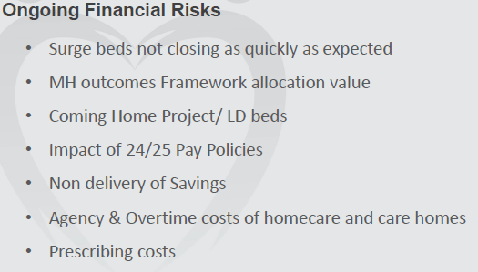

Lynn Gallagher (Borders Carers Centre) – requested that the budget allocated for carers support to be identified in the budget. Chris Myers mentioned that this is reported in the full annual accounts. The next financial update to be provided at the November meeting.

Lucy O’Leary welcomed Peter Moore, Chief Executive Officer NHS Borders to his new role.

Comments:

The new Local Area Co-ordination service has a stronger community focus with building community capacity being a key element of their work. Partnerships with third-sector organisations and community groups are essential for this new stage of development. Possibility of joint funding applications for community based projects and avoidance of duplication needs to be considered.

Actions from this meeting:
Juliana liaising with Age Friendly Communities to provide a presentation at the next IJB in November.

Distribution list for information:
BCA Team + Third Sector Leaders

Signed: J Amaral

