Strategic meeting:
Integration Joint Board

Date of meeting:  19/11/2024 | Attended by:  J Amaral
Relevant agenda items:

Health and Social Care Partnership Performance and Delivery Report
Health and Social Care Winter Planning
Quarter 2 Update and 2025/26 Forward Plan

Specific points of interest:

Health and Social Care Partnership Performance and Delivery Report
Chris Myers provided an overview of the Health and Social Care Partnership delivery against its Strategic Framework and Annual Delivery Plan. Overall, good progress is being made in relation to the implementation of both the Annual Delivery Plan, and the Directions issued by the Integration Joint Board. Two areas have been highlighted as having significant delivery challenges:

- The first relates to the integration of Home First with Adult Social Care. There have been delays involved in this complex transformation project associated to the need to ensure appropriate staff governance, consider differences in pay terms and conditions, and current service overspend. Progress is being made through the review and a further update is noted below.
- The second relates to the Delayed Discharge and Surge Plan which has previously been reported on. Significant work is being progressed that is outlined in Appendix 1
- The third relates to the financial position.

Progress has been noted on the reduction of social work assessments particularly on the communities team. Hospital assessments are still outstanding. The success of the communities’ reduction on waiting lists has been attributed to the What Matters Hubs.

In terms of unpaid carers and carers assessment, Lynn Gallager (Carers Centre) provided an update on carers assessment. The centre has been offering 180-225 carer support plans per quarter with 120-205 being completed.
Lynn highlighted the main challenge regarding people being able to access care, particularly respite and carer support due to shortage of options and system overload.

Discharge without delay is improving mitigating challenges in care capacity particularly in MH and nursing care.

Measuring patients’ needs – there was a wider discussion around post diagnostic support and Power of Attorney and the impact on further delays in discharge.
A comms campaign is being circulated promoting people to think ahead of POA – Cllr Thorton-Nichol demanded that the message is done as a matter of urgency and is widely spread across communities.

Other highlights: winter planning (in the agenda) – discussion held at Wellbeing Programme Board.
The Pathfinder pilot in Cheviot is about reducing risk to people who are identified as high-risk individuals.

Financial update:
As noted in the NHS Borders Finance Report presented to their Board on 3rd October 2024 NHS Borders face a financial gap of £24.76m for 2024/25. Although some of this is expected to be addressed through brokerage from the Scottish Government it is anticipated that between £8.8m and £10.0m will require another funding source.
In November SBC reported a forecast unfunded pressure of c£4m in year with additional savings of £1.9m still to be delivered from reducing, stopping or delaying spend and activity before 31 March. Whilst the Council currently has a balanced indicative plan for 2025/26 it is acknowledged that this position will be very challenging to maintain as costs and demands are anticipated to increase but funding is not. The Budget Update paper presented to Council on 24 October 2024 notes ‘The forthcoming budget round will be very challenging for the Council given significant cost pressures including pay, inflation and ongoing service demand pressures. Latest forecasts indicate a budget gap of £50m over the next 10 years’

Health and Social Care Winter Planning
Chris Myers presented the Health and social care winter planning which delivered 11 sessions and had 60+ staff consulted.
Main concerns identified:
- Pressure on systems – staff capacity
- Managing public expectation
- Emphasis on keeping people well at home. Discharge without delay has with numbers being reduced
What we can do to help:
- Patient care and hospital avoidance – emphasis on keeping people at home
- Streamlined processes - including discharge, referral process / access to social care
- Improved discharge coordination
- Interdepartmental collaboration
- Staffing and resources – focused on the right place
- Staff wellbeing initiatives – breaks, social events, wellbeing focus, vaccination uptake
- Public messaging – robust signposting, alternative services
- Winter actions: update on discussions at Wellbeing Programme Board: food and fuel support to those most at risk and in need. Preventative approach

Priority 1 – Take a preventative approach to those most at risk of a crisis including hospital admission:
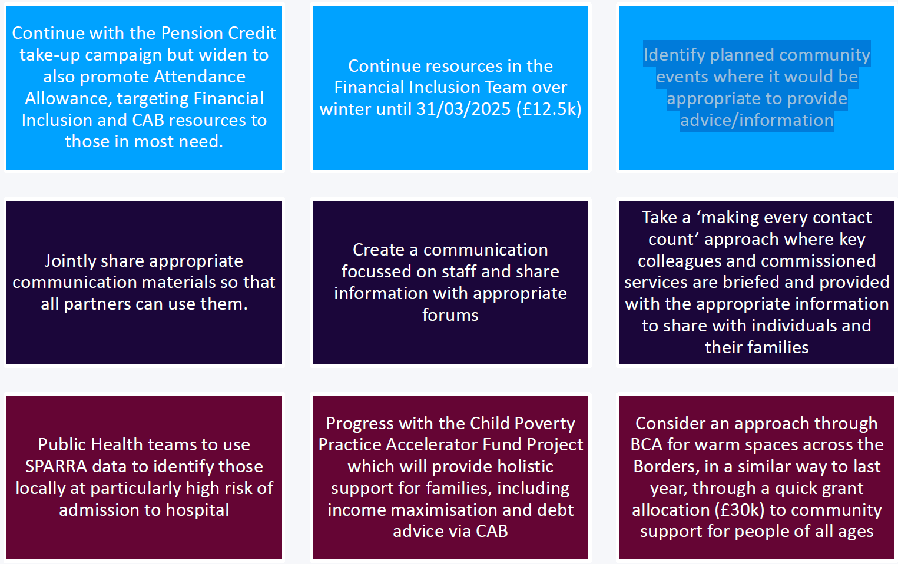

Priority 2 – Respond to those most in need
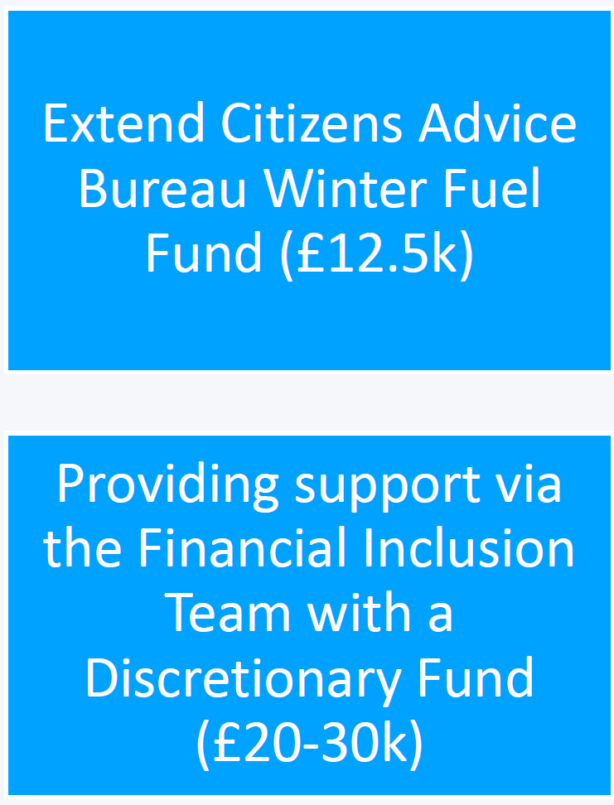
Continue implementing the Communications & Engagement Plan – internal and external
Continue to engage and update teams and services – ‘You said, We did’
Further modelling work will be undertaken to mitigate a reduction of DDs, and capacity provided by community-based services
Finalise the Winter Plan – approval at BET 26/11
Sign off at Board in early December 5/12

Actions from this meeting:
BCA to prepare Warm Spaces funding distribution in anticipation of approval

Distribution list for information:
BCA Team + Third Sector Leaders

Signed: J Amaral

