Strategic meeting:
Community Planning Strategic Board

Date of meeting:  14/11/2024 | Attended by:  J Amaral
Relevant agenda items:

- Community Learning and Development Strategic Plan update – Gillian Jardine
- Population Health Framework – Dr Sohail Bhatti
- CPP Governance and Operating Framework Update Clare Malster
- Community Plan Delivery Groups Progress Reports:
(a) Theme 1 – Poverty; Jenni Craig
(b) Theme 2 – Learning, skills & economy; Lana Turner
(c) Theme 3 – Good health & wellbeing
(d) Theme 4 – Place, community & connectivity; Juliana Amaral
- Self-assessment update

Specific points of interest:

- Action tracker: Juliana provided a brief overview of the third sector mapping and gapping employability
Project. The survey received 57 responses and a range of in-person sessions were delivered across localities in the Borders. Data is being compiled to present to the LEP in a report and an online directory of employability provision across Borders.

- Community Learning and Development Partnership – The specific focus of this one-year plan on governance, shared delivery, data collection and celebrating learning, responds to those improvements we know we must and need to make.
The Community Learning and Development Partnership is a multi-agency group responsible for setting the strategic direction for CLD and has oversight of the delivery of CLD in the Scottish Borders. The Partnership is also responsible for implementing relevant legislation along with national strategy and priorities. The Partnership acts on behalf of the Community planning Partnership (CPP) and reports directly to the CPP.
The membership of the Partnership was refreshed in 2024, and a new Chair is in position along with new members. Current partners are listed below:

Title | Organisation
Director Resilient Communities Scottish Borders Council | Director Resilient Communities Scottish Borders Council
Public Health – Health Improvement Lead NHS Borders | Public Health – Health Improvement Lead NHS Borders
Chief Executive Officer Borders Community Action | Chief Executive Officer Borders Community Action
Community Co-ordinator (2) Scottish Borders Council | Community Co-ordinator (2) Scottish Borders Council
CLD Team Leader (2) Scottish Borders Council | CLD Team Leader (2) Scottish Borders Council
Community Liaison Lead Officer Police Scotland | Community Liaison Lead Officer Police Scotland
Chief Executive Officer Youth Borders | Chief Executive Officer Youth Borders
Quality Improvement Officer Scottish Borders Council | Quality Improvement Officer Scottish Borders Council
Area Manager Skills Development Scotland | Area Manager Skills Development Scotland
Director of Enterprise and Business | Director of Enterprise and Business
Innovation | Innovation
Borders College | Borders College
CLD Officer Scottish Borders Council | CLD Officer Scottish Borders Council
Employability Lead Officer Scottish Borders Council | Employability Lead Officer Scottish Borders Council

- Population Health Framework – Dr Sohail Bhatti
Purpose - To accelerate the improvement and recovery of population health in Scotland through a coherent long-term framework of whole system, primary preventative action.
What would add value?
Coherent narrative on the drivers of health inequalities and the need for upstream, primary prevention.
Evidence on future threats and preventative actions that lead to measurable improvement in population health.
A Framework, that:
Sets out our national aims, priorities & approach
Builds on recent strategic plans, identifies gaps and where there is added value in collective action
Has flexibility to frame future action in response to new challenges
New actions, approaches or programmes for improvement that will deliver change – focussed on agreed priority areas.
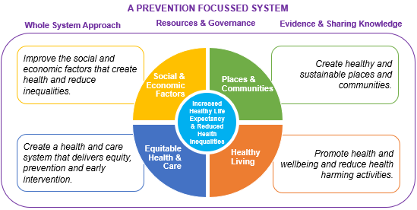

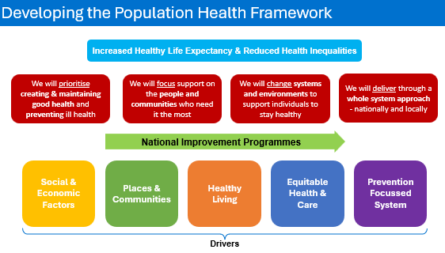
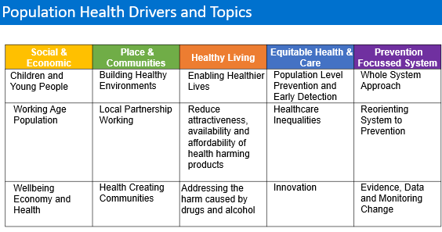
- Community Plan Delivery group updates

Theme one – Poverty: Following mapping of actions to address poverty that are currently being delivered by partners, this report sets out an indication of the large range of work that is currently being undertaken to address poverty in the Scottish Borders. However, it should be noted that some information is still to be submitted and that there are more actions taking place than recorded here. This should be read alongside the Scottish Borders Child Poverty Action Progress Report which collates actions specifically relating to children, young people, parents and families, which was presented to the Strategic Board in June this year.
The Wellbeing Programme, overseen by the multi-agency Wellbeing Board, has been established to review the wellbeing services and activities operating throughout the Scottish Borders to identify and address any gaps, and to help services work closer together to complement each other’s work. The Programme has four high impact priorities including social Issues of Living (including Poverty and Inequality). Progress to date includes the agreement that an asset-based community development approach would be used in the Scottish Borders as it will allow the Health and Social Care Partnership to collectively better support collaboration, coordination and partnership, and support community
engagement. Work currently taking place includes the creation of a programme of key interventions for people in winter fuel and food poverty.
As the work of the Wellbeing Board progresses links will be made between it and the Community Planning Partnership to avoid duplication. As there is no multi agency anti-poverty strategy, that covers all demographics living in the Borders, it will be recommended to
Council that the CPP be asked to endorse the Strategy. A muti agency focus on delivering and monitoring the Strategy will support the CPP to add value to the existing actions and meet the outcome in the Community Plan which is to: Help mitigate against the financial challenges of day to day living for those who are most affected.

Theme 2 – Learning, Skills & Economy:
Subgroups: Barriers, Transitions, Employer Engagement, Skills, Leadership. The following projects are currently under way:
Transitions projects:

Borders Family Firm - supporting Care Experienced Young People aged 16 – 25 years.
Supported Employment – all age support to overcome barriers into employment.
Parental Employability Services (PES) – offering 1:1 employability support to priority families.
Intensive Family Support Service (IFSS) – support offered to young families helping parents provide a better environment for their young people and progression opportunities for every family member.
DFN Project Search - supporting young people aged 16-29 with additional needs to gain skills and experience for employment
ASN Transitions Development Officer (BANG)
Transitions Subgroup / Borders College
Works+ - 16 – 24 Employability
(Berwickshire)

Skills
Mapping and Gapping Project – Borders Community Action
ReTweed – Skills for Work
Bruce Robertson Training Ltd- CSCS
Brothers of Charity Services Scotland – Pre-Employment Core Skills
MacArts – Introduction to Careers in Live Entertainment
Live Learn Earn – Target the Position,Train for the Job
Employability Day Event
Job Fair

Barriers
SBC – Your Family, Your Voice – parent support
Driving Theory and Driving Test Support
Children 1st
Live Borders – Employability Programme
SBC – Work Learn Go!

Digital connectivity
Chrome Books
SIM Cards
Mobile Connectivity
Assistance with IT Issues

Theme 3 – Health and Wellbeing
Combination between theme 3 and theme 4 next meeting happening 19/09 continued support for the social prescribing work happening in the Borders.

Quarterly Partnership Updates:
- Community Justice Partnership
- CLD Strategic Partnership
- Children & Young People’s Planning Partnership

The recommendations in THIS (The Health Improvement Strategy) Borders have been developed to align with the Theme 3 outcomes in the Community Plan:
• Improved access to effective services, particularly for those who face greater challenges accessing services
• Reduced health inequalities for those experiencing the greatest negative impact
• Fewer people experiencing domestic abuse

Theme 4 – Place, Community & Connectivity
The delivery group identified that progress is being made across the other key priorities under theme 4.
Digital inclusion was therefore identified as a key priority since although there seem to be pockets of
good work happening, there’s not enough knowledge about what is available and where the gaps are
across the Scottish Borders.
The delivery group discussed the digital inclusion charter launched in August. The Charter has recently
been refreshed and relaunched. Previous signatories, and those who hadn’t signed up before, are being
asked to do so and agree to the five pledges.
Scotland's Digital Inclusion Charter
The delivery group also agreed to explore progress made and learn from Dumfries and Galloway
experience as a result of the Digital Exclusion report. This would enable the delivery group to identify key
actions for the Scottish Borders.
The next meeting of the delivery group in November will focus on digital inclusion.

Actions from this meeting:
Meeting with Selkirk Councillors outstanding, Juliana waiting for dates and Cllrs availability

Distribution list for information:
BCA Team + Third Sector Leaders

Signed: J Amaral

