Strategic meeting:
Community Planning Strategic Board

Date of meeting:  04/11/2024 | Attended by:  J Amaral
Relevant agenda items:

- Feedback from CPP Delivery Board and Education Sub-Committee
- Scottish Borders Anti Poverty Strategy 24/29
- Review of Action Tracker and Target setting
- Quarterly Reporting - Sharon
- Talk Money Week – Nichola Sewell

Specific points of interest:

CLD draft plan has been presented and endorsed by CPP Programme Board. Papers will be sent to CPP Strategic partnership meeting in November. Jenni emphasised the importance of a website to keep information on track and consolidate in one point all the resources and info available.

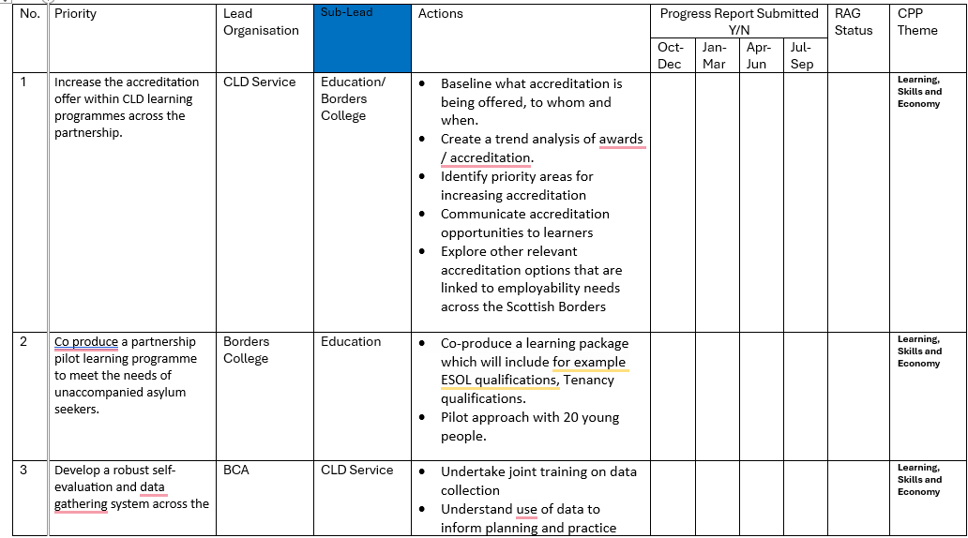
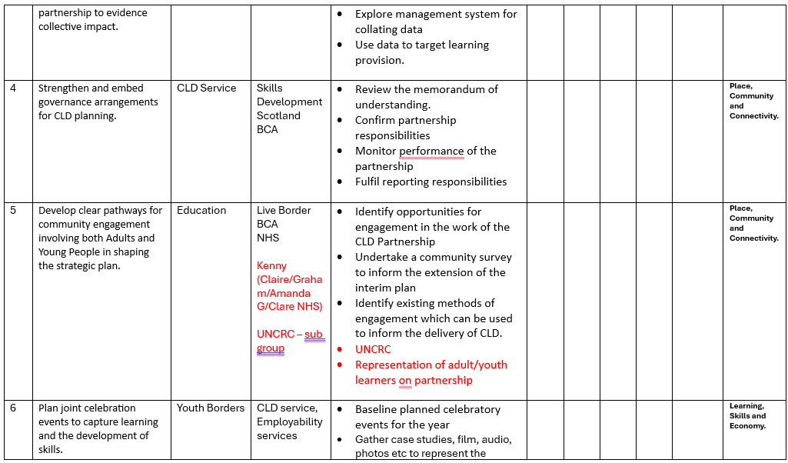
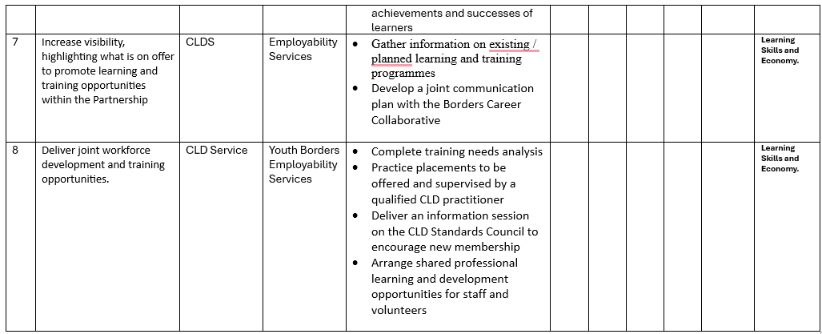

Anti-poverty strategy – Elected members’ meeting on 24/10 highlighted the amount of work happening across the partnership to tackle poverty across the Scottish Borders. The plan is to agree on strong actions to ensure the delivery of the strategy.
Teviot & Liddesdale area partnership is making the strategy the main point of discussion at the meeting, which links with the development plan for Burnfoot.

The partners reviewed in detail the draft actions of the plan, looking at the identified priorities and leads of each priority as well as actions. Agreed tasks were reviewed.

Reporting documentation was covered and a template was shared among partners. Juliana and Gillian to meet and discuss digitalisation to ensure reporting is easier across the membership.

Nichola Sewell (NHS Borders) – provided an update Health Matters App and its alignment with the poverty strategy.

December meeting to be a facilitation from Education Scotland around monitoring and evaluation.

Comments:
The new CLD plan will be presented at the CPP Strategic Board meeting in November. Partners are moving on with actions with the first reporting planned for December

Actions from this meeting:
Juliana and Gillian to discuss reporting and data gathering

Distribution list for information:
BCA Team + Third Sector Leaders

Signed: J Amaral

