Strategic meeting:
Wellbeing Programme Board

Date of meeting:  01/10/2024 | Attended by:  J Amaral
Relevant agenda items:

- Wellbeing Pathways Workshop Update
- Warm and Well Update
- Collaboration for Health Equity in Scotland (CHES)
- Any Other Business

Specific points of interest:

Wellbeing Pathways Workshop Update:
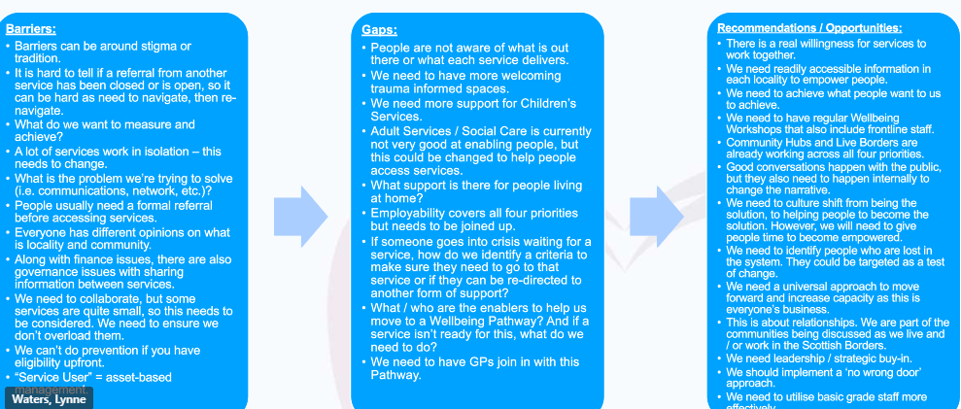

Main barriers: lack of knowledge of what’s happening and who is doing what. Different views of opinions and understanding of communities, culture shift – services led, silo working.
Gaps: accessibility, some services are very small which causes problems in service outreach and provision, GPs need to be linked to what’s happening. Identify enablers of positive pathways.
Opportunities: collaboration, accessible information, no wrong door approach.

Wide discussion around advancing the social prescribing agenda in the Borders either targeting areas of deprivation for pilot projects or looking at locality events to gather information about what can be done to enable people to look after their well-being.

Warm and Well – funding was put in place for Citizens’ Avice in the Borders to put together a winter fuel fund to support people in crisis. This fund is still in place but predicted to run out in December 2024. Registered Social Landlords have also been doing similar work with tenants including a warmth advisor.
SBC – financial inclusion team also supports people with crisis payments and provision of Scottish Welfare fund.
SBC community engagement is also pushing for pension credits to support those impacted by the reduction of winter fuel payments.

Third Sector funding has been made available through Borders Community Action (£40K) and Youth Borders (£96K) in previous years.

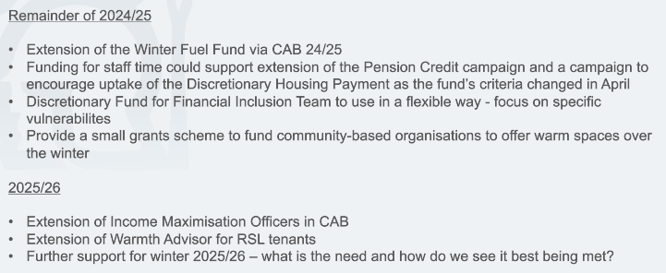

Discussion around prioritisation of the financial inclusion team to support people in accessing benefits such as Pension Credit to support those impacted by the winter fuel payment cuts.

Collaboration for Health Equity in Scotland (CHES) - The Collaboration for Health Equity in Scotland (CHES) is a project that has been developed by Public Health Scotland and the Institute of Health Equity. It will use the eight principles of Sir Michael Marmot (known as the ‘Marmot Eight’ principles) to create three Marmot Places within Scotland. A Marmot Place recognises that health and health inequalities are mostly shaped by the social determinants of health (SDH): the conditions in which people are born, grow, live, work and age, and takes action to improve health and reduce health inequalities. The ‘Marmot Eight’ principles are:​

- ​Give every child the best start in life.​
- Enable all children, young people and adults to maximise their capabilities and have control over their lives.​
- Create fair employment and good work for all.​
- Ensure a healthy standard of living for all.​
- Create and develop healthy and sustainable places and communities.​
- Strengthen the role and impact of ill health prevention.​
- Tackle racism, discrimination and their outcomes.​
- Pursue environmental sustainability and health equity together.

An application submitted by the Integrated Joint Board for the Scottish Borders.

Actions from this meeting:
Juliana to circulate the Scottish Government report for the Communities Mental Health and Wellbeing fund

Distribution list for information:
BCA Team + Third Sector Leaders

Signed: J Amaral

