Meetings Feedback form for Borders Community Action Representatives

Name and purpose of meeting: Strategic Action Group

Date of meeting: 07/06/24 | Attended by:  - Juliana Amaral – Borders Community Action  Organisation and role Name  Glenkens Community & Arts Trust Helen Keron  Scottish Borders Council Cllr Jenny Linehan (Chair)  SOSE - Chair Professor Russel Griggs  SBC – Director of Infrastructure and Environment John Curry  SBC – Place and Enterprise Manager Graeme Johnstone  D&GC / SWestrans Tom Flanagan  SWestrans Grant Coltart  SOSE – Strategy Manager, Infrastructure and Investment Tom Bishop  SOSE – Director of Strategy, Partnerships and Engagement Karen Jackson  SEStran – Partnership Director Brian Butler  NHS Borders – Head of Facilities Fiona Laidlaw  Scottish Borders Community representative Keith Dickinson  Borders Community Action Juliana Amaral  Visit Scotland – Destination Development Director, South of Scotland Gordon Smith  South of Scotland Destination Alliance – CEO David Hope Jones  Third Sector D&G – Chief Executive, Glencairns Community Arts Trust Helen Keron  SBC/ ESESCRD – Workforce Mobility Project Lead Ewan Doyle  SOSE – Head of Energy Transition Paul Wheelhouse  SOSE – Head of Economy and Insight David Ford  SOSE / SOSREP – Secretariat Louise Hann
Relevant agenda items:

- Membership of the Strategic Action Group Transport (SAGT)
- Re-set of the strategic action group for transport

Comments:

- Membership of the Strategic Action Group Transport (SAGT)
Juliana enquired if Borders Community Transport has been included in the membership

- SBC Strategic transport priorities
Scottish Borders Bus Network review: a presentation on the review undertaken between September 22 and June 2023
Focus was placed on challenges in relation to financial pressures, increase in operating costs and opportunities around partnership work between SBC, NHS Borders and Borders College – to include community transport.
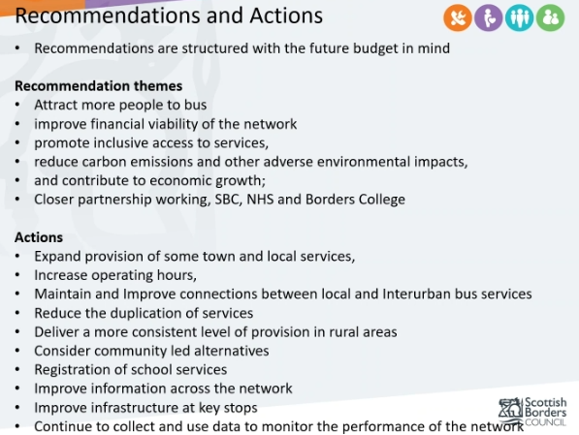

- Active Travel –
Graham Johnston (SBC) provided an update on the active travel position, which is a Scottish government requirement for local authorities. Budget has been reduced despite active travel still being a priority for the Scottish Government.
Tier 1 and 2 Funding to Local Authorities to enable capital investment
Tier 3 cities and urban areas to support infrastructure support
Tier 4 behaviour change
Coast to Coast project in the south of Scotland, networks for walking cycling and riding. Connectivity between rail and bus, 20 minutes neighbourhood
Not enough revenue investment at the moment
Rural equivalent of the 20-minute neighbourhood
Development of transport hubs

- Workforce Mobility (Ewan Doyle)
EV charging across rural areas, a plan has been developed following stakeholder engagement. 230 charging points are required to be installed between now and 2030. Issues are gaps in the funding.
Procurement strategy for EV infrastructure, aimed at creating economies of scale.
Wider discussion around the procurement process, the challenges and the support required to develop this plan.
Data Analysis – Bus patronage Data, Employee Postcode, Mobile Phone data, business accessibility data.
Juliana raised the issue of older-aged demographics and representation in the data capturing tools used.
The answer was that data is missing, Fiona Laidlaw from NHS Borders has been gathering some.
Juliana left the meeting at 10 am.
Actions from this meeting:

- None
Distribution list for information:

- Borders Community Action membership

Signed: Juliana Amaral

